Software Requirements Specification (SRS)
Document Details
Project | Automated Meeting Minutes Generator (AMMG)
Version | 1.0
Authors | Sriranga Bharadwaj (PES1UG24AM286)  Srijan Akshit (PES1UG24AM284)  Swasthik Pamadi (PES1UG24AM298)  Siddhanth Khurdiya (PES1UG24AM275)
Date | 06-10-2026
Status | Draft for review

Table of Contents
1. Introduction 4
1.1 Purpose 4
1.2 Scope 4
1.3 Audience 4
1.4 Definitions 5
2. Overall Description 5
2.1 Product Perspective 5
2.2 Major Product Functions 6
2.3 User Roles and Characteristics 6
2.4 Operating Environment 6
2.5 Constraints 6
3. External Interface Requirements 7
3.1 User Interfaces 7
3.2 Hardware Interfaces 7
3.3 Software Interfaces 7
3.4 Communications 7
4. System Features (Detailed) 8
4.1 Authentication & Access Management 8
Description 8
4.2 Meeting & Audio Input 8
Description 8
4.3 Speech-to-Text & Speaker Identification 9
Description 9
4.4 Content Analysis (Discussions, Decisions, Action Items) 10
Description 10
4.5 Minutes Generation, Editing & Sharing 11
Description 11
4.6 Action Item Tracking 12
Description 12
4.7 Administration & Data Management 13
Description 13
5. Non-Functional Requirements (Detailed) 13
5.1 Security 14
5.1.1 Security Objectives 14
5.1.2 Security Requirements 15
6. Quality Attributes & Acceptance Tests 16
7. System Models and Diagrams 16
7.1 UML Use-Case Diagrams 16
7.2 Use-Case Summary 18
8. Requirements Traceability Matrix (RTM) 19

Note: This Table of Contents is generated via field codes. To ensure page-number accuracy after editing, right-click the TOC and select "Update Field".

1. Introduction

1.1 Purpose
This document is the Software Requirements Specification for the Automated Meeting Minutes Generator (AMMG). It defines the functional and non-functional requirements, interfaces, security requirements and verification criteria of a system that converts meeting audio into text and produces editable, structured meeting minutes containing key discussions, decisions, action items, responsible people and deadlines.
The document serves as the baseline for design, implementation, testing and acceptance of the AMMG project. Every requirement carries a unique identifier, an acceptance criterion and a reference test case so that coverage can be traced end to end through the Requirements Traceability Matrix in section 8.

1.2 Scope
AMMG is a web application. A user creates a meeting, uploads or records the audio, and the system transcribes it, identifies speakers, extracts discussion topics, decisions, action items, owners and deadlines, and generates minutes the user can edit, export (DOCX, PDF, Markdown) and share by email. It also tracks action items across meetings.
Out of scope: live (real-time) captioning during a meeting, video analysis, integration with video-conferencing platforms (e.g. joining Zoom/Teams calls as a bot), and training of new speech models.

1.3 Audience
- Developers
- QA engineers
- Project guide / evaluators
- System administrators
- End users (meeting organisers and participants)

1.4 Definitions
Term | Meaning
AMMG | Automated Meeting Minutes Generator
ASR | Automatic Speech Recognition (speech-to-text)
WER | Word Error Rate - ASR accuracy measure
Diarization | Splitting audio by who is speaking
NLP | Natural Language Processing
Action item | A task assigned to a person, usually with a deadline
MoM | Minutes of Meeting
RBAC | Role-Based Access Control
JWT | JSON Web Token
TLS | Transport Layer Security
API | Application Programming Interface
RTM | Requirements Traceability Matrix
UI | User Interface

2. Overall Description

2.1 Product Perspective
AMMG is a self-contained web system with a browser front end, a REST back end, asynchronous AI workers (audio pre-processing, ASR, diarization, NLP extraction), a relational database and object storage. It sends email through an external SMTP server. It does not depend on any particular meeting platform; recordings come from file upload or the browser microphone.

2.2 Major Product Functions
- Register, log in and manage access by role
- Create meetings with agenda and attendee list
- Upload or record meeting audio; validate and normalise it
- Transcribe speech with timestamps; identify speakers; edit transcript
- Extract key discussions, decisions, action items, owners and deadlines with confidence scores
- Generate structured, editable minutes with version history and source links
- Export (DOCX / PDF / Markdown) and share minutes by email
- Track action items across meetings and send reminders
- Administer jobs, retention and deletion of data

2.3 User Roles and Characteristics
- Organizer: creates meetings, uploads audio, edits and shares minutes; non-technical, wants minutes quickly and with few corrections.
- Participant / Action item owner: views minutes and own action items, updates status; occasional user.
- Admin: manages users, monitors processing jobs, sets retention policy; technically skilled.
- External systems: speech/NLP models (internal workers) and SMTP email server.

2.4 Operating Environment
Server: Linux (Docker containers), Python 3.11+, PostgreSQL, Redis, S3-compatible storage; GPU recommended for ASR (CPU fallback supported at lower speed). Client: current versions of Chrome, Edge, Firefox and Safari on desktop and mobile; microphone access is required only for browser recording.

2.5 Constraints
- Meeting audio is confidential: self-hosted models by default; no content is sent to third parties without opt-in (AMG-SR-009).
- ASR/NLP accuracy depends on audio quality, accents and overlapping speech; every extracted item must therefore be editable.
- Maximum recording size 500 MB / 3 hours.
- The project must be delivered using open-source components within the academic schedule.
- Assumption: the attendee list is supplied by the Organizer; speakers are matched to names by the user.

3. External Interface Requirements

3.1 User Interfaces
Responsive web UI with screens: Login/Register, Meetings list, Meeting details (agenda, attendees), Upload/Record, Processing status, Transcript view with audio player and speaker labels, Minutes editor (topics, decisions, action-item table with low-confidence highlighting), Export/Share dialog, Action dashboard, and Admin console. The interface is keyboard navigable, high-contrast and conforms to WCAG 2.1 AA.

3.2 Hardware Interfaces
- Client microphone via browser MediaRecorder API (optional).
- Server GPU (CUDA) for ASR/diarization acceleration (optional).

3.3 Software Interfaces
- Speech recognition: Whisper-class model (e.g. faster-whisper) running in a worker.
- Speaker diarization: pyannote.audio-class model.
- NLP extraction: spaCy + dateparser + an instruction-tuned language model run locally.
- FFmpeg for audio conversion.
- PostgreSQL (data), Redis (job queue), S3-compatible object storage (audio, exports).
- SMTP server for notifications; python-docx / PDF library for export.
- Internal REST API (JSON over HTTPS) between UI and back end, documented in OpenAPI.

3.4 Communications
TLS 1.2+ for all traffic; JWT bearer tokens; chunked/resumable upload for large files; job status via polling (WebSocket optional); long-running work is asynchronous via the job queue with retry and back-off.

4. System Features (Detailed)
Each requirement has an acceptance criterion and a reference test case. Functional IDs follow AMG-F-###. Total functional requirements: 28.

4.1 Authentication & Access Management

Description
Register and authenticate users and restrict every meeting to the people entitled to see it.
Req ID | Requirement | Type | Priority | Source /  Stakeholder | Acceptance Criteria / Test Case Ref | Comments /  Depend.
AMG-F-001 | The system shall allow a user to register and log in with email and password, and shall verify the email address before first use. | Functional | High | Organizer | AC-AMG-F-001: Valid credentials create a session; invalid credentials are rejected with a generic message. Test: TC-Auth-01 | Email service required
AMG-F-002 | The system shall enforce role-based access (Admin, Organizer, Participant) so that a user can open only meetings they own or were invited to. | Functional | High | Security | AC-AMG-F-002: Access to another user's meeting returns HTTP 403. Test: TC-Auth-02 | Depends on F-010 attendee list
AMG-F-003 | The system shall lock an account for 15 minutes after 5 consecutive failed logins and record an audit event. | Functional | Medium | Security | AC-AMG-F-003: 6th attempt is refused during the lock period; event present in audit log. Test: TC-Auth-03 | See AMG-SR-008

4.2 Meeting & Audio Input

Description
Capture meeting metadata and the audio/video recording, validate it and track processing.
Req ID | Requirement | Type | Priority | Source /  Stakeholder | Acceptance Criteria / Test Case Ref | Comments /  Depend.
AMG-F-010 | The system shall let an Organizer create a meeting record with title, date/time, agenda and attendee list (name, email). | Functional | High | Organizer | AC-AMG-F-010: Meeting saved and listed with all entered fields. Test: TC-Mtg-01 | Attendees used later for owner resolution
AMG-F-011 | The system shall accept upload of recordings in MP3, WAV, M4A and MP4 format up to 500 MB or 3 hours. | Functional | High | Organizer | AC-AMG-F-011: Supported files upload with progress bar; larger/unsupported files are refused with a message. Test: TC-Aud-01 | Chunked upload recommended
AMG-F-012 | The system shall allow recording audio directly in the browser with start, pause, resume and stop controls. | Functional | Medium | Organizer | AC-AMG-F-012: Recorded audio is saved to the meeting and playable. Test: TC-Aud-02 | Needs microphone permission
AMG-F-013 | The system shall validate each recording (format, size, corruption, near-silence) and convert it to 16 kHz mono WAV, rejecting invalid files with a clear error. | Functional | High | Developer | AC-AMG-F-013: Corrupt or silent file is rejected; valid file is normalised. Test: TC-Aud-03 | FFmpeg
AMG-F-014 | The system shall display processing status (Queued, Transcribing, Analysing, Ready, Failed) and allow the Organizer to retry a failed job. | Functional | Medium | Organizer | AC-AMG-F-014: Status updates within 5 s of each stage change; Retry restarts the job. Test: TC-Aud-04 | Job queue

4.3 Speech-to-Text & Speaker Identification

Description
Convert speech to a time-stamped, speaker-labelled transcript that users can correct.
Req ID | Requirement | Type | Priority | Source /  Stakeholder | Acceptance Criteria / Test Case Ref | Comments /  Depend.
AMG-F-020 | The system shall transcribe the recording into text with a start/end timestamp for every segment. | Functional | High | Organizer | AC-AMG-F-020: Transcript produced for entire audio; WER <= 15% on the clean-speech test set. Test: TC-Tr-01 | Whisper-class ASR model
AMG-F-021 | The system shall identify distinct speakers (diarization), label them Speaker 1..n and allow the user to map each label to an attendee. | Functional | High | Organizer | AC-AMG-F-021: Each segment carries a speaker label; renaming a label updates all its segments. Test: TC-Tr-02 | Needed for F-033
AMG-F-022 | The system shall show the transcript synchronised with audio playback and allow the user to edit text and speaker labels. | Functional | High | Organizer | AC-AMG-F-022: Clicking a segment seeks audio; edits persist after reload. Test: TC-Tr-03
AMG-F-023 | The system shall let the user choose the spoken language (English or Hindi) per meeting before transcription. | Functional | Medium | Organizer | AC-AMG-F-023: Selected language is passed to the ASR model and shown on the transcript. Test: TC-Tr-04 | Hindi accuracy may be lower

4.4 Content Analysis (Discussions, Decisions, Action Items)

Description
Identify key discussions, decisions, action items, responsible people and deadlines from the transcript.
Req ID | Requirement | Type | Priority | Source /  Stakeholder | Acceptance Criteria / Test Case Ref | Comments /  Depend.
AMG-F-030 | The system shall divide the transcript into key discussion topics, each with a title, a short summary and a timestamp range. | Functional | High | Organizer | AC-AMG-F-030: At least 80% of reference topics are found in the evaluation meetings. Test: TC-NLP-01
AMG-F-031 | The system shall identify decisions made in the meeting and record each as a decision statement with its context. | Functional | High | Organizer | AC-AMG-F-031: Decisions in annotated sample are detected with recall >= 0.75. Test: TC-NLP-02
AMG-F-032 | The system shall detect action items and record each with a task description and a link to its source segment. | Functional | High | Organizer | AC-AMG-F-032: Action-item F1 >= 0.75 on annotated sample. Test: TC-NLP-03
AMG-F-033 | The system shall assign a responsible person to each action item by resolving names, speaker labels and pronouns to attendees, or mark it 'Unassigned'. | Functional | High | Organizer | AC-AMG-F-033: Owner correct for >= 80% of items with a stated owner; otherwise 'Unassigned'. Test: TC-NLP-04 | Needs attendee list (F-010) and speaker mapping (F-021)
AMG-F-034 | The system shall extract deadlines and convert relative expressions (e.g. 'by next Friday') into absolute dates using the meeting date. | Functional | High | Organizer | AC-AMG-F-034: 'next Friday' in a meeting dated 02-10-2026 resolves to 09-10-2026. Test: TC-NLP-05 | dateparser library
AMG-F-035 | The system shall give every extracted item a confidence score and highlight items below 0.6 for user review. | Functional | Medium | Organizer | AC-AMG-F-035: Low-confidence items visibly flagged in the editor. Test: TC-NLP-06

4.5 Minutes Generation, Editing & Sharing

Description
Produce structured, editable minutes and export or share them.
Req ID | Requirement | Type | Priority | Source /  Stakeholder | Acceptance Criteria / Test Case Ref | Comments /  Depend.
AMG-F-040 | The system shall generate structured minutes containing meeting details, attendees, discussion summary, decisions and an action-item table (task, owner, deadline, status). | Functional | High | Organizer | AC-AMG-F-040: Minutes generated automatically when analysis completes, with all sections. Test: TC-Min-01
AMG-F-041 | The system shall provide an editor in which the user can edit, add, delete and reorder any minutes item, with changes auto-saved. | Functional | High | Organizer | AC-AMG-F-041: Edits survive page reload within 5 s of change. Test: TC-Min-02
AMG-F-042 | The system shall link each decision and action item to its transcript segment and audio timestamp. | Functional | Medium | Participant | AC-AMG-F-042: Clicking the link plays the audio at that moment. Test: TC-Min-03
AMG-F-043 | The system shall keep a version history of minutes and allow reverting to an earlier version. | Functional | Medium | Organizer | AC-AMG-F-043: Each save creates a version; revert restores its content. Test: TC-Min-04
AMG-F-044 | The system shall export minutes as DOCX, PDF and Markdown. | Functional | High | Organizer | AC-AMG-F-044: Exported files open correctly and match the on-screen content. Test: TC-Min-05
AMG-F-045 | The system shall email finalised minutes to all attendees with an attachment or secure link. | Functional | Medium | Organizer | AC-AMG-F-045: Every attendee receives the email; failures are logged. Test: TC-Min-06 | SMTP server

4.6 Action Item Tracking

Description
Follow up action items across meetings.
Req ID | Requirement | Type | Priority | Source /  Stakeholder | Acceptance Criteria / Test Case Ref | Comments /  Depend.
AMG-F-050 | The system shall provide a dashboard of action items across meetings, filterable by owner, status and due date. | Functional | Medium | Participant | AC-AMG-F-050: Filters return only matching items. Test: TC-Act-01
AMG-F-051 | The system shall email reminders to action-item owners one day before the deadline and let owners update item status. | Functional | Low | Participant | AC-AMG-F-051: Reminder sent 24 h before due date; status update visible to Organizer. Test: TC-Act-02 | Scheduler

4.7 Administration & Data Management

Description
Operate the system and control data retention.
Req ID | Requirement | Type | Priority | Source /  Stakeholder | Acceptance Criteria / Test Case Ref | Comments /  Depend.
AMG-F-060 | The system shall let an Admin monitor processing jobs (queue length, failure rate) and restart failed jobs. | Functional | Medium | Operations | AC-AMG-F-060: Admin console lists jobs and restarts a failed one. Test: TC-Adm-01
AMG-F-061 | The system shall allow an Organizer to delete a meeting with its audio, transcript and minutes, and shall auto-delete audio after a configurable retention period (default 90 days). | Functional | High | Security / Privacy | AC-AMG-F-061: Deleted data no longer retrievable; scheduled purge removes expired audio. Test: TC-Adm-02 | See AMG-SR-009

5. Non-Functional Requirements (Detailed)
NFRs are measurable and tied to test cases. IDs follow AMG-NF-###.
Req ID | Requirement | Category | Priority | Acceptance Criteria / Measurement
AMG-NF-001 | End-to-end processing (upload complete to minutes ready) shall take no longer than 0.5x the audio duration for recordings up to 60 minutes under normal load. | Performance | High | Measured on reference server over 10 test recordings. Test: TC-Perf-01
AMG-NF-002 | Transcription word-error rate shall be <= 15% on clean English speech, and action-item extraction F1 shall be >= 0.75 on the annotated evaluation set (20 meetings). | Accuracy | High | Evaluation script results meet both thresholds. Test: TC-Acc-01
AMG-NF-003 | The system shall be available 99% of each month, excluding scheduled maintenance. | Reliability | Medium | Uptime monitor report >= 99%. Test: TC-Ops-01
AMG-NF-004 | A first-time user shall be able to upload a recording and obtain minutes without training, with a System Usability Scale score >= 70. | Usability | High | SUS survey with >= 5 users. Test: TC-UX-01
AMG-NF-005 | The system shall support 100 concurrent users and 20 concurrent processing jobs; excess jobs shall be queued, not rejected. | Scalability | Medium | Load test shows no failed requests. Test: TC-Perf-02
AMG-NF-006 | The web interface shall work on the latest two versions of Chrome, Edge, Firefox and Safari and be usable on screens >= 360 px wide. | Compatibility | Medium | Cross-browser checklist passes. Test: TC-Cmp-01
AMG-NF-007 | The code shall be modular with >= 70% unit-test coverage and a documented OpenAPI specification for all REST endpoints. | Maintainability | Medium | Coverage report and OpenAPI file reviewed. Test: TC-Mnt-01
AMG-NF-008 | The user interface shall conform to WCAG 2.1 AA (keyboard navigation, contrast, labels). | Accessibility | Medium | Automated (axe) and manual audit pass. Test: TC-UX-02

5.1 Security

5.1.1 Security Objectives
- SO-1 Confidentiality: Meeting audio, transcripts and minutes often contain sensitive business information; only authorised attendees may read them, in storage and in transit.
- SO-2 Integrity: Minutes, action items and the audit trail must not be altered without authorisation and every change must be attributable.
- SO-3 Availability & abuse resistance: The service must stay usable under heavy or malicious load (large uploads, brute force) through limits and queueing.
- SO-4 Privacy & accountability: Recordings are kept only as long as needed, can be deleted on request, and security-relevant actions are logged.

5.1.2 Security Requirements
Req ID | Requirement (shall...) | Type | Priority | Acceptance Criteria / Test Case Ref
AMG-SR-001 | TLS 1.2 or higher shall be mandatory for all client-server and service-to-service connections. | Security | High | AC: HTTP is redirected to HTTPS; TLS 1.0/1.1 handshakes fail. Test: TC-Sec-01
AMG-SR-002 | Audio files, transcripts and minutes shall be encrypted at rest with AES-256. | Security | High | AC: Stored objects are unreadable without the key. Test: TC-Sec-02
AMG-SR-003 | Passwords shall be stored only as salted Argon2id (or bcrypt) hashes. | Security | High | AC: Database inspection shows no plaintext passwords. Test: TC-Sec-03
AMG-SR-004 | Access tokens (JWT) shall expire after 30 minutes, refresh tokens shall rotate on use, and logout shall invalidate the session. | Security | High | AC: Expired or revoked token returns 401. Test: TC-Sec-04
AMG-SR-005 | Every API call shall verify on the server that the caller is entitled to the requested meeting (no insecure direct object references). | Security | High | AC: Changing a meeting ID in the URL to another user's returns 403. Test: TC-Sec-05
AMG-SR-006 | Uploads shall be validated by MIME type and file signature, size-limited, virus-scanned and stored under random names. | Security | High | AC: Renamed .exe or oversize file is rejected. Test: TC-Sec-06
AMG-SR-007 | The API shall rate-limit requests (100/min/user; 10/min on login) and return HTTP 429 when exceeded. | Security | Medium | AC: 11th login attempt in a minute returns 429. Test: TC-Sec-07
AMG-SR-008 | Login, share, export, delete and role-change events shall be written to a tamper-evident audit log retained for one year. | Security | Medium | AC: Events are present, time-stamped and read-only. Test: TC-Sec-08
AMG-SR-009 | Recording data shall be processed by self-hosted models; no audio or transcript shall be sent to a third-party service unless the organisation explicitly opts in. Deleted audio shall be purged from storage and backups within 7 days. | Security | High | AC: No outbound calls with content in network capture; purge verified. Test: TC-Sec-09
AMG-SR-010 | All user input and generated text shall be sanitised/escaped to prevent XSS and injection, and the app shall send CSP and other security headers. | Security | High | AC: OWASP ZAP baseline scan has no high findings. Test: TC-Sec-10

6. Quality Attributes & Acceptance Tests
- Exit criteria for acceptance: all High-priority functional requirements implemented and verified, no critical or high-severity defects open, NFR-001 and NFR-002 thresholds met, and the RTM shows all test cases passed.
- Acceptance test suites: Authentication, Audio input, Transcription, Content extraction, Minutes editing/export, Action tracking, Administration, Performance, Accuracy, Security and Accessibility.
- Evaluation dataset: at least 20 recorded meetings (public meeting corpora and self-recorded mock meetings) manually annotated with topics, decisions, action items, owners and deadlines, used to measure WER and extraction F1.

7. System Models and Diagrams

7.1 UML Use-Case Diagrams
Two UML use-case diagrams are defined for AMMG: use-case diagram 1 covers the core meeting-minutes generation flow, and use-case diagram 2 covers action tracking and administration. Actors, use cases and their include relationships are shown below.
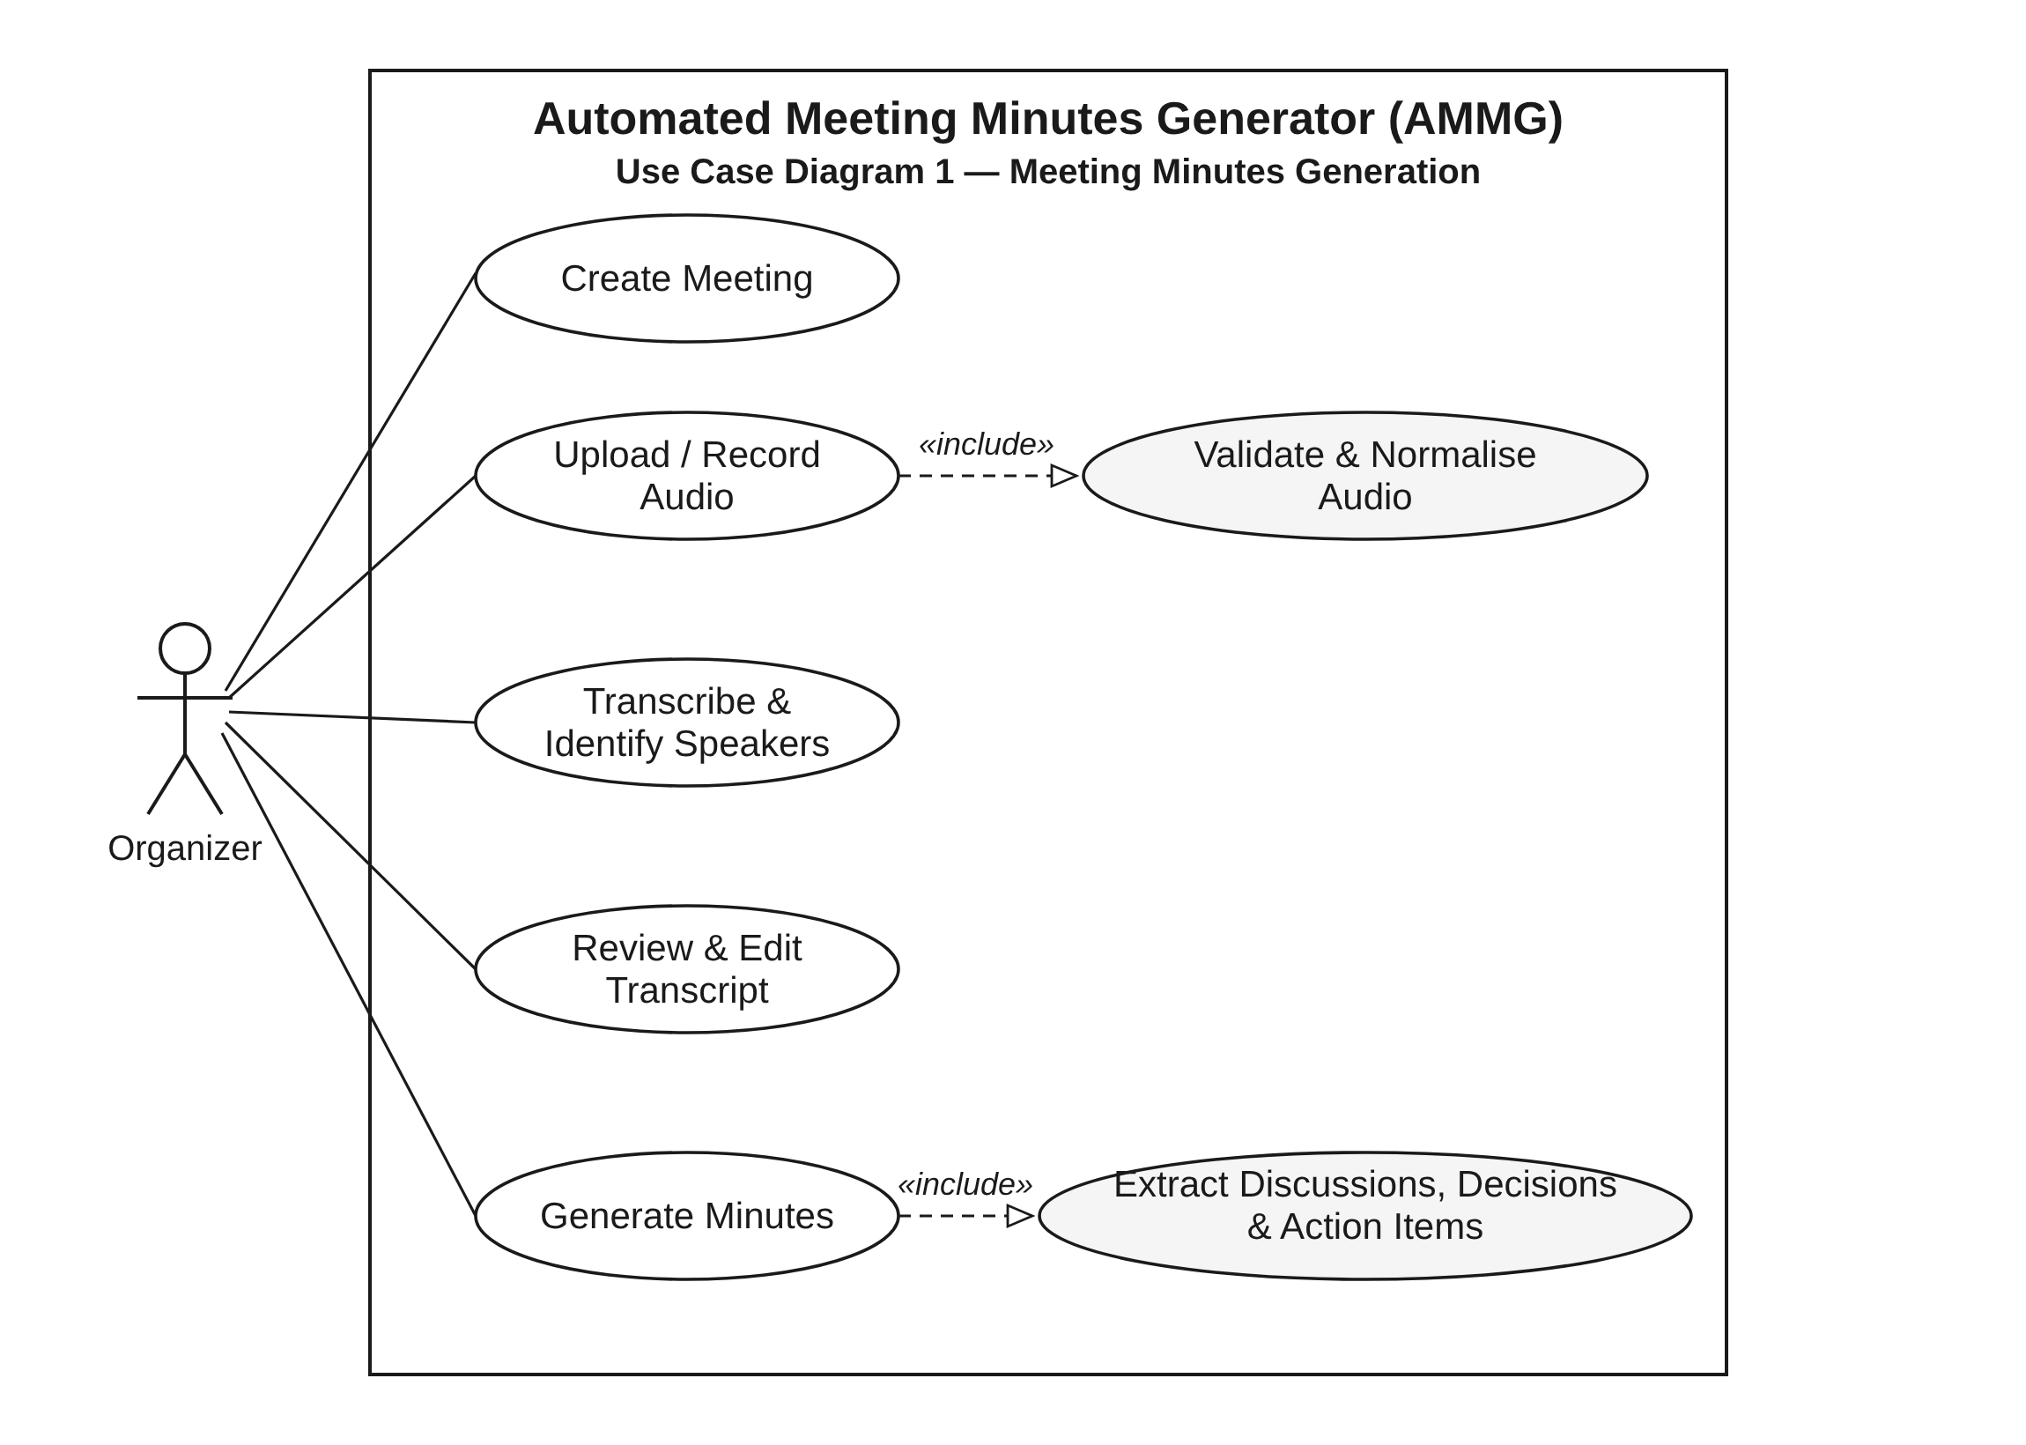
Figure 1: Use-case diagram - Meeting Minutes Generation
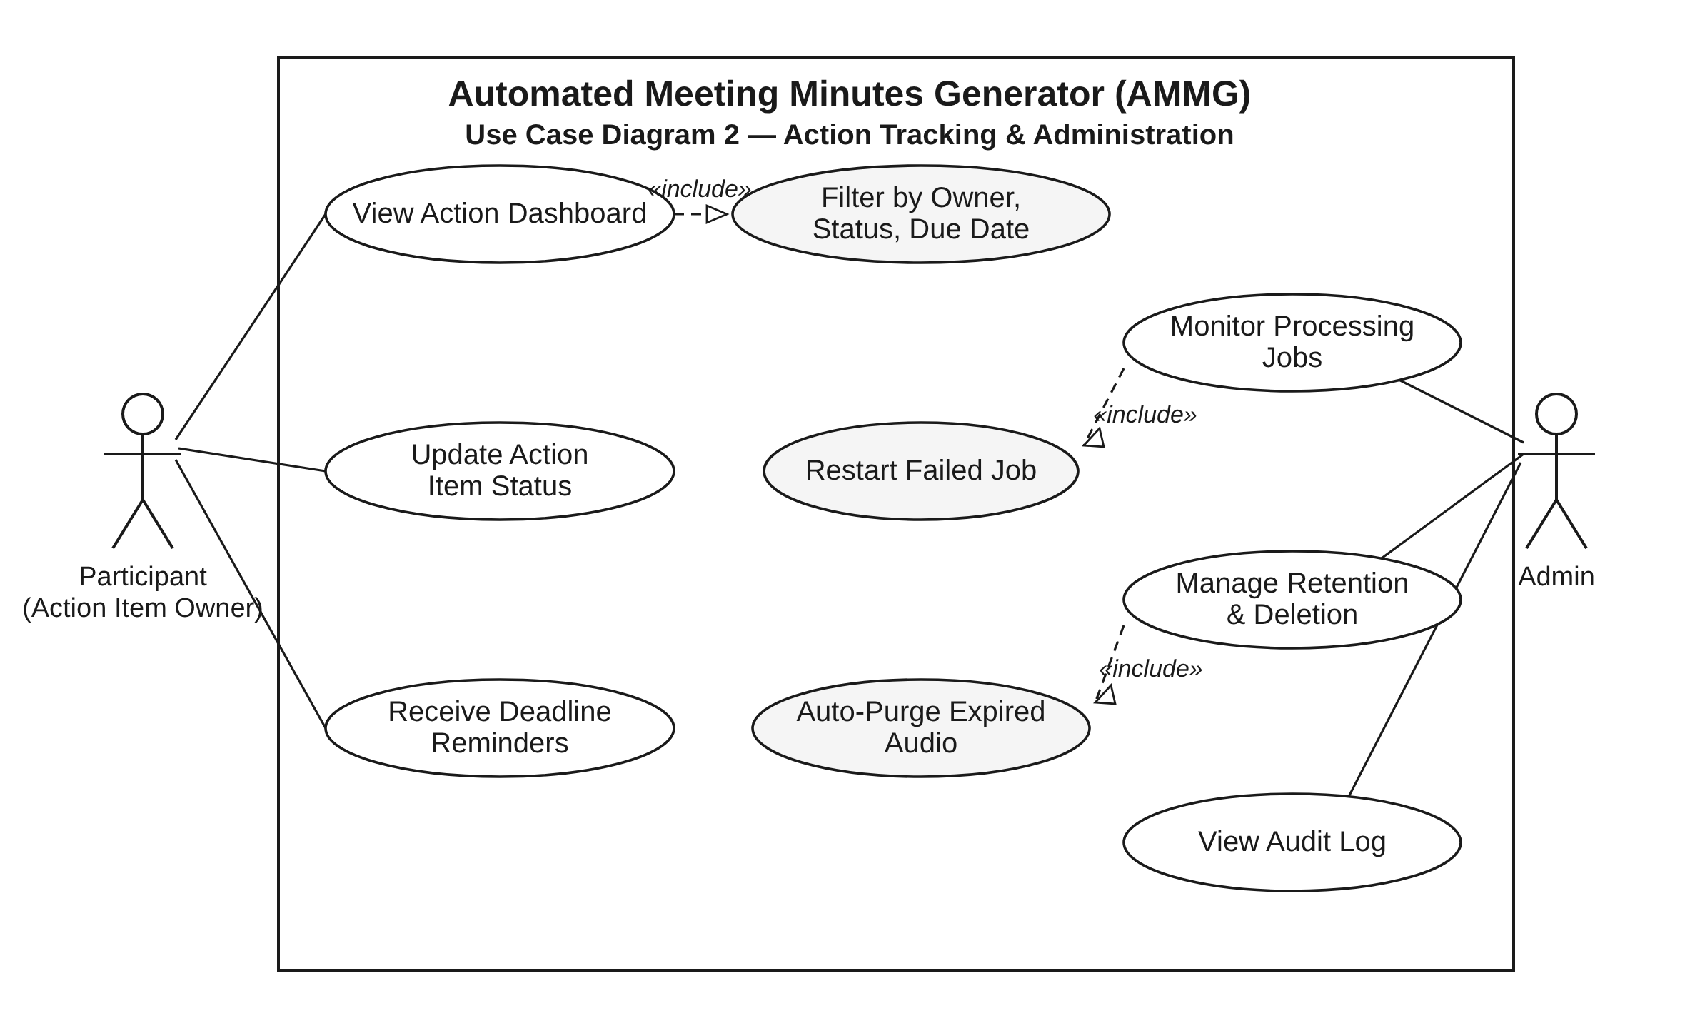
Figure 2: Use-case diagram - Action Tracking & Administration

7.2 Use-Case Summary
Use case | Primary actor | Main flow (summary) | Related reqs
Generate minutes from recording | Organizer | Create meeting -> upload/record audio -> system transcribes, identifies speakers, extracts items -> minutes generated | F-010..F-014, F-020, F-021, F-030..F-035, F-040
Review and edit | Organizer | Open transcript/minutes -> correct text, owners, deadlines -> autosave -> version created | F-022, F-041..F-043
Export and share | Organizer | Choose format -> download, or share with attendees by email | F-044, F-045
Follow up actions | Owner | Open dashboard -> filter own items -> update status; receive reminder | F-050, F-051
Administer system | Admin | Monitor jobs -> restart failed -> set retention -> review audit log | F-060, F-061, SR-008

8. Requirements Traceability Matrix (RTM)
The RTM maps every SRS requirement to its design element, implementing module and covering test cases. Status: N = Not started, P = Partially implemented, A = Accepted. All 46 requirements (28 functional, 8 non-functional and 10 security) have at least one mapped test case.
Req ID | Requirement short | Section ref /  Design Spec | Module | Test case(s) | Status  (N/P/A) | Comments
AMG-F-001 | Register / login | 4.1 / DS-AuthModule | AuthModule | TC-Auth-01 | N
AMG-F-002 | Role-based access | 4.1 / DS-AuthModule | AuthModule | TC-Auth-02 | N
AMG-F-003 | Account lockout | 4.1 / DS-AuthModule | AuthModule | TC-Auth-03 | N | See AMG-SR-008
AMG-F-010 | Create meeting | 4.2 / DS-MeetingModule | MeetingModule | TC-Mtg-01 | N
AMG-F-011 | Upload recording | 4.2 / DS-AudioProcessor | AudioProcessor | TC-Aud-01 | N
AMG-F-012 | Browser recording | 4.2 / DS-WebUI | WebUI | TC-Aud-02 | N
AMG-F-013 | Validate & normalise audio | 4.2 / DS-AudioProcessor | AudioProcessor | TC-Aud-03 | N
AMG-F-014 | Processing status | 4.2 / DS-MeetingModule | MeetingModule | TC-Aud-04 | N
AMG-F-020 | Speech-to-text | 4.3 / DS-TranscriptionService | TranscriptionService | TC-Tr-01 | N
AMG-F-021 | Speaker identification | 4.3 / DS-DiarizationService | DiarizationService | TC-Tr-02 | N
AMG-F-022 | Edit transcript | 4.3 / DS-WebUI | WebUI / TranscriptionService | TC-Tr-03 | N
AMG-F-023 | Language selection | 4.3 / DS-TranscriptionService | TranscriptionService | TC-Tr-04 | N
AMG-F-030 | Key discussions | 4.4 / DS-NLPAnalyzer | NLPAnalyzer | TC-NLP-01 | N
AMG-F-031 | Decisions | 4.4 / DS-NLPAnalyzer | NLPAnalyzer | TC-NLP-02 | N
AMG-F-032 | Action items | 4.4 / DS-NLPAnalyzer | NLPAnalyzer | TC-NLP-03 | N
AMG-F-033 | Responsible person | 4.4 / DS-NLPAnalyzer | NLPAnalyzer | TC-NLP-04 | N | Needs F-010, F-021
AMG-F-034 | Deadlines | 4.4 / DS-NLPAnalyzer | NLPAnalyzer | TC-NLP-05 | N | dateparser library
AMG-F-035 | Confidence scores | 4.4 / DS-NLPAnalyzer | NLPAnalyzer | TC-NLP-06 | N
AMG-F-040 | Generate minutes | 4.5 / DS-MinutesGenerator | MinutesGenerator | TC-Min-01 | N
AMG-F-041 | Editable minutes | 4.5 / DS-WebUI | WebUI / MinutesGenerator | TC-Min-02 | N
AMG-F-042 | Source linking | 4.5 / DS-MinutesGenerator | MinutesGenerator | TC-Min-03 | N
AMG-F-043 | Version history | 4.5 / DS-MinutesGenerator | MinutesGenerator | TC-Min-04 | N
AMG-F-044 | Export | 4.5 / DS-ExportService | ExportService | TC-Min-05 | N
AMG-F-045 | Share by email | 4.5 / DS-NotificationService | NotificationService | TC-Min-06 | N | SMTP server
AMG-F-050 | Action dashboard | 4.6 / DS-ActionTracker | ActionTracker | TC-Act-01 | N
AMG-F-051 | Reminders & status | 4.6 / DS-NotificationService | NotificationService | TC-Act-02 | N | Scheduler
AMG-F-060 | Job monitoring | 4.7 / DS-AdminModule | AdminModule | TC-Adm-01 | N
AMG-F-061 | Delete & retention | 4.7 / DS-AdminModule | AdminModule | TC-Adm-02 | N | See AMG-SR-009
AMG-NF-001 | Processing time <= 0.5x audio length | 5 / DS-Performance | WebUI / Workers | TC-Perf-01 | N
AMG-NF-002 | WER <= 15%; action-item F1 >= 0.75 | 5 / DS-Accuracy | ASR / NLPAnalyzer | TC-Acc-01 | N
AMG-NF-003 | 99% monthly availability | 5 / DS-Reliability | Platform | TC-Ops-01 | N
AMG-NF-004 | Unaided first use; SUS >= 70 | 5 / DS-Usability | WebUI | TC-UX-01 | N
AMG-NF-005 | 100 concurrent users; 20 concurrent jobs | 5 / DS-Scalability | API / Queue | TC-Perf-02 | N
AMG-NF-006 | Latest two versions of major browsers; >= 360 px | 5 / DS-Compatibility | WebUI | TC-Cmp-01 | N
AMG-NF-007 | >= 70% unit-test coverage; OpenAPI spec | 5 / DS-Maintainability | All | TC-Mnt-01 | N
AMG-NF-008 | WCAG 2.1 AA conformance | 5 / DS-Accessibility | WebUI | TC-UX-02 | N
AMG-SR-001 | TLS 1.2+ mandatory | 5.1 / DS-Security | Security controls | TC-Sec-01 | N
AMG-SR-002 | AES-256 encryption at rest | 5.1 / DS-Security | Security controls | TC-Sec-02 | N
AMG-SR-003 | Argon2id / bcrypt password hashes | 5.1 / DS-Security | Security controls | TC-Sec-03 | N
AMG-SR-004 | JWT expiry 30 min; refresh rotation | 5.1 / DS-Security | Security controls | TC-Sec-04 | N
AMG-SR-005 | Server-side entitlement checks (no IDOR) | 5.1 / DS-Security | Security controls | TC-Sec-05 | N
AMG-SR-006 | Upload validation, virus scan, random names | 5.1 / DS-Security | Security controls | TC-Sec-06 | N
AMG-SR-007 | Rate limiting with HTTP 429 | 5.1 / DS-Security | Security controls | TC-Sec-07 | N
AMG-SR-008 | Tamper-evident audit log, 1-year retention | 5.1 / DS-Security | Security controls | TC-Sec-08 | N
AMG-SR-009 | Self-hosted models; 7-day purge | 5.1 / DS-Security | Security controls | TC-Sec-09 | N
AMG-SR-010 | XSS/injection sanitisation; CSP headers | 5.1 / DS-Security | Security controls | TC-Sec-10 | N

